1 Port 698-2690MHz Indoor Omni Antenna

Applications:
- 698-2690MHz
- Omni antenna
Features:
- Wide band
Connector:
- N-Female

Electrical specifications
Frequency range (MHz) | 698-960 | 1710-2690
Polarization | Vertical | Vertical
Gain(dBi) | 2 | 6
Horizontal beam-width(°) | 360 | 360
3dB Vertical beam-width(°) | 65 | 45
VSWR | ≤1.8
Intermodulation IM3(dBc) | ≤-150dBc(@2*43dBm)
Impedance(Ω) | 50
Maximum input power(W) | 50
Lightning protection | DC grounded

Mechanical specifications
Connector | 1×N-Female
Connector position | Bottom
Size(mm) | Φ 186x 85
Gross weight(kg) | 0.42
Wind resistance(km/h) | 210
Reflector material | Aluminium
Radome material | ABS
Radome color | Gray
Operating temperature(℃) | -40～65
Waterproof | IP65
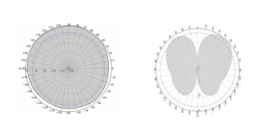

2690MHz

